31.2: a) 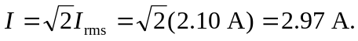
b) 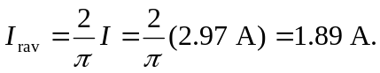
c) The root-mean-square voltage is always greater than the rectified average, because squaring the current before averaging, then square-rooting to get the root-mean-square value will always give a larger value than just averaging.

